Understanding Bio-energetic Testing and the Qest4

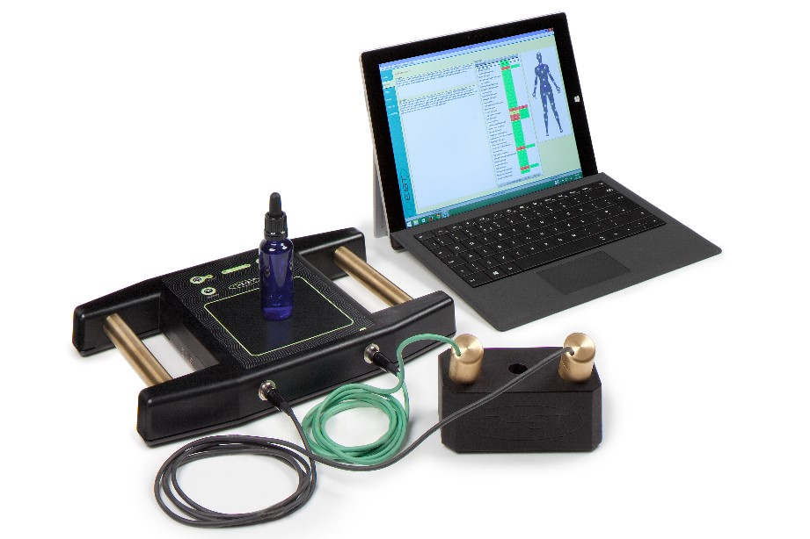

Everything in existence is made up of energy!
Medicine has recognized that we are electro-magnetic beings and has a tradition of using diagnostic machines, such as MRIs, which work with magnetic energy.
Ultrasound machines use high frequency sound energy. An Electrocardiogram (EKG) and an Electroencephalography (EEG) are electronic representations of what is in the heart and the brain.
The Qest4 Bio-Energetic Testing System is one of the most powerful electro-dermal testing systems available today. With the use of handheld electrodes, it can measure the energetic signatures (imbalances) of the body and determine the presence of environmental toxicities, food sensitivities, vertebrae misalignments, dental concerns, as well as bacteria, viruses and pathogens long before conventional tests may find them.
When these frequency imbalances are detected, a person can proactively make lifestyle changes that give their body the proper fuel to overcome these imbalances, often before symptoms physically present.
Bio-energetic testing does not diagnose. It presents a completely individualized set of responses at a specific point in time to the challenges that were included in the test. This information can often be used to help support a traditional diagnosis, but the main purpose is to identify imbalances and create a plan to address those imbalances and improve health.
More than 70% of people who visit a medical practice suffer from what is known as a functional disturbance. In simple terms, a functional disturbance occurs when no specific tissue or organ damage can be identified by conventional blood tests or traditional pathological diagnostic testing, and yet the patient continues to experience multiple symptoms. Where traditional approaches end, the Qest4 system introduces a new perspective, effectively utilizing the technology of bio-energetic screening.
Many people can benefit greatly from the insight obtained through bio-energetic testing. Research concerning bio-energetic testing has been well documented in university studies using various methods of traditional diagnostics.

